Course Project Report

IOT Based Home Automation System

Mobin Azimi, Sepehr Ahmadian and Reza Shahriari

**Did you Know!!**

****SmartThings that can be found in your Samsung smartphones is a very good example of successful home automation app. SmartThings was conceived by co-founder and once-CEO Alex Hawkinson in the winter of 2011. Hawkinson tells that his family's unoccupied mountain house in Colorado was extensively damaged by water pipes that first froze and subsequently burst resulting in some $80,000 worth of damage. Hawkinson stated he could have prevented the damage had he known beforehands. His works is now know as smartThings which can be found in every Samsung smartphones as of 2014.

|  |
| --- |
|  |

**Abstract:** In this paper we are discussing how to design and implement a simple home automation system based on IOT. This Report has three main chapters (Phases) in the first Chapter we define the main goals, describe the project, items needed (such as sensors, etc.), topology of some recommended circuits , how to connect different parts of the circuit together , etc.

1. Chapter (Phase) I

This chapter mainly concerns the how-to of the project , some theoretical ideas , available and recommended circuits and The Chosen Circuit.

1. Introduction

**What is smart home and Why have a smart home? What are we going to do ?**

**About IOT :**

Features of IOT

Advantages of IOT

Disadvantages of IOT

Applications of IOT

IOT Protocols

**About Sensors :**

Sensor I : LDR (Light Dependant Diode)

Use in our project

Sensor II : Encoder (Coupled with the actuator)

Use in our project

Sensor III : Temperature and humidity sensor

Use in our project

Sensor IV : Gas Sensor

Use in our project

Sensor V : Proximity Sensor

Use in our project

Sensor Networking : Different Topology

**About Actuator :**

The 6-Volt Motor

The LED

The Alarm LED

**About the MCU :**

What do we want from an MCU

What are some recommended MCUs for our use

NodeMCU

**About the interface :**

How to Watch and Monitor

How to Control

1. **Chapter (Phase II) :**

This Chapter is about simulating our design. We have used Proteus software and Arduino UNO as our simulation board.

**2. Getting to Know the Sensors :**

**Light Dependant Resistor (LDR) :**

How Does it Work?

Simulation

**Motion Encoder (Coupled With the Actuator) :**

How Does it Work?

Simulation

**Temperature and Humidity Sensor (DHT22):**

How Does it Work?

Simulation

**Gas Sensor**

How Does it Work?

Simulation

**Proximity Sensor**

How Does it Work?

Simulation

1. **Chapter (Phase) III :**

In this Chapter We want to implement what we have learned in the previous chapters. We have overcome some serious obstacles , we identified our actuator. deriving its Transfer Function , and using our design criterion , we have controlled it.

**3. Getting to know the actuator :**

Deriving the transfer function (System Identification)

Designing the Controller using Root-Locus Criterion

ICACHE_RAM_ATTR error : Reasons and Solution

Designing a minimal Realization : Controllable and Observable

Simulating Process and Instrumentation Noise

Testing the Performance of Kalman Filter in the Presence of Noise

**4. Setting Up the WebServer :**

What is an HMI?

How to use HMI

WebServer with the use of Personal Hotspot

HTML/CSS/JS Code Discription

Designing a simple web-based Monitoring System

**5.Getting Started with the Hardware:**

Wiring Explained

About the L298N Motor driver

Coding Explained

**What is smart home and why have a smart home**

A smart home means your home has a smart home system that connects with your appliances to automate specific tasks and is typically remotely controlled. You can use a smart home system to program your sprinklers, set and monitor your home security system and cameras, or control appliances like your refrigerator or air conditioning and heating. Having a smart home has following benefits :

Smart homes allow you to have greater control of your energy use, all while automating things like adjusting temperature, turning on and off lights, opening and closing window treatments, and adjusting irrigation based on the weather.

Smart homes provide insights into energy use that can help you become more energy efficient and mindful of ecological factors.

Smart homes can pinpoint areas where you’re using more energy than you need to, allowing you to cut back in those areas and save money.

They can help homeowners prevent and minimize damage. Smart thermostats can help prevent pipes from freezing. Smart-leak detectors can shut off water if they detect moisture. Smart smoke and carbon monoxide detectors can notify you through an app and potentially save your life and your home.

They’re convenient for those who are aging, disabled or have limited mobility Smart locks can alleviate the common problem of being locked out due to lost or forgotten keys. Smart lighting systems can “learn” your patterns and switch lights on and off at appropriate times. Home healthcare equipment, such as monitoring and diagnostic tools, can simplify the caregiving process. For example, some sensors and devices may help you monitor the movements of an aging or disabled relative and ensure their safety.

As opposed to those benefits stated above there are some disadvantages about Home Automation systems.

It’s difficult to link systems from different vendors. Many manufacturers develop distinct systems, making it difficult to integrate new devices with your existing ones made by a different brand. Integrating different devices from different vendors may result in limited functionality and unreliable service.

The systems can be costly. The market is expanding and costs are decreasing, but many systems still come with a hefty price tag. Most devices cost several hundred dollars each; the cost of a complete home upgrade could be thousands of dollars.

These devices have security flaws and can be hacked. In early 2015, one tech company tested 16 home automation devices and found only one that its researchers couldn’t easily break into. Some companies that make these products don’t have strong backgrounds in security. There are currently no industry standards for security on these devices. If cyber criminals breaks into your home devices, they can learn your patterns of behavior and use that to their advantage.

|  |  |
| --- | --- |
|  |  |
|  |  |

**What are we going to do in this Project :**

In this project we aim at designing , simulating and implementing a simple model of a home automation system. The main idea is use a small development board called NodeMCU. Supplying voltage to the board and programming the MCU using Arduino app , we can program ESP8266 to take command from an interface (here we may use Blynk or other android-based applications) we use multiple sensors , (i.e. in a Wheatstone bridge ) to get data from them , processing it sending signals accordingly to light an LED or to control speed and direction of a DC motor.

**About IOT :**

The Internet of things (IoT) describes physical objects (or groups of such objects) with sensors, processing ability, software and other technologies that connect and exchange data with other devices and systems over the Internet or other communications networks. Internet of things has been considered a misnomer because devices do not need to be connected to the public internet, they only need to be connected to a network, and be individually addressable.

The field has evolved due to the convergence of multiple technologies, including ubiquitous computing, commodity sensors, increasingly powerful embedded systems, as well as machine learning. Traditional fields of embedded systems, wireless sensor networks, control systems, automation (including home and building automation), independently and collectively enable the Internet of things.

In the consumer market, IoT technology is most synonymous with products pertaining to the concept of the "smart home", including devices and appliances (such as lighting fixtures, thermostats, home security systems, cameras, and other home appliances) that support one or more common ecosystems, and can be controlled via devices associated with that ecosystem, such as smartphones and smart speakers. IoT is also used in healthcare systems.

There are a number of concerns about the risks in the growth of IoT technologies and products, especially in the areas of privacy and security, and consequently, industry and governmental moves to address these concerns have begun, including the development of international and local standards, guidelines, and regulatory frameworks.

**Features of IoT :**

***Intelligence*** *:*

IOT comes with the combination of algorithms and computation, software & hardware that makes it smart. Ambient intelligence in IOT enhances its capabilities which facilitate the things to respond in an intelligent way to a particular situation and supports them in carrying out specific tasks. In spite of all the popularity of smart technologies, intelligence in IOT is only concerned as a means of interaction between devices, while user and device interaction are achieved by standard input methods and graphical user interface.

***Connectivity :***

Connectivity empowers the Internet of Things by bringing together everyday objects. Connectivity of these objects is pivotal because simple object level interactions contribute towards collective intelligence in the IOT network. It enables network accessibility and compatibility in the things. With this connectivity, new market opportunities for the Internet of things can be created by the networking of smart things and applications

***Dynamic Nature :***

The primary activity of Internet of Things is to collect data from its environment, this is achieved with the dynamic changes that take place around the devices. The state of these devices change dynamically, example sleeping and waking up, connected and/or disconnected as well as the context of devices including temperature, location and speed. In addition to the state of the device, the number of devices also changes dynamically with a person, place and time.

***Enormous Scale :***

The number of devices that need to be managed and that communicate with each other will be much larger than the devices connected to the current Internet. The management of data generated from these devices and their interpretation for application purposes becomes more critical. Gartner (2015) confirms the enormous scale of IOT in the estimated report where it stated that 5.5 million new things will get connected every day and 6.4 billion connected things will be in 14 | P a g e use worldwide in 2016, which is up by 30 percent from 2015. The report also forecasts that the number of connected devices will reach 20.8 billion by 2020.

***Sensing :***

IOT wouldn’t be possible without sensors that will detect or measure any changes in the environment to generate data that can report on their status or even interact with the environment. Sensing technologies provide the means to create capabilities that reflect a true awareness of the physical world and the people in it. The sensing information is simply the analog input from the physical world, but it can provide a rich understanding of our complex world.

***Heterogeneity :***

Heterogeneity in Internet of Things as one of the key characteristics. Devices in IOT are based on different hardware platforms and networks and can interact with other devices or service platforms through different networks. IOT architecture should support direct network connectivity between heterogeneous networks. The key design requirements for heterogeneous things and their environments in IOT are scalabilities, modularity, extensibility and interoperability.

***Security :***

IOT devices are naturally vulnerable to security threats. As we gain efficiencies, novel experiences, and other benefits from the IOT, it would be a mistake to forget about security concerns associated with it. There is a high level of transparency and privacy issues with IOT. It is important to secure the endpoints, the networks, and the data that is transferred across all of it means creating a security paradigm.

**Advatages Of IoT :**

***Communication :***

IOT encourages the communication between devices, also famously known as Machine-to-Machine (M2M) communication. Because of this, the physical devices are able to stay connected and hence the total transparency is available with lesser inefficiencies and greater quality.

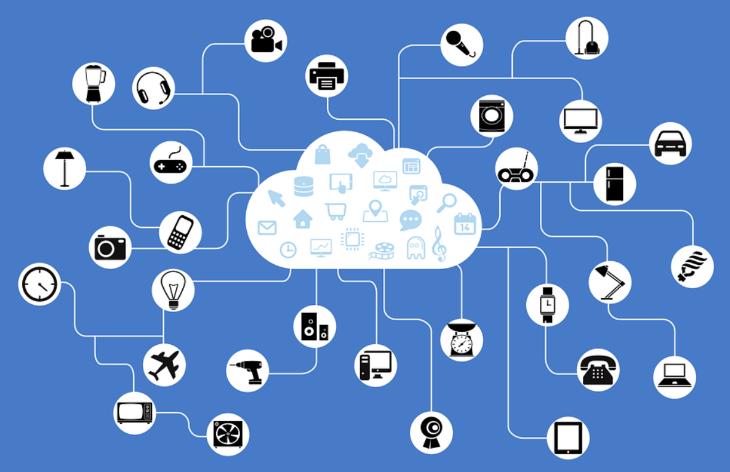

***Automation and Control :***

Due to physical objects getting connected and controlled digitally and centrally with wireless infrastructure, there is a large amount of automation and control in the workings. Without human intervention, the machines are able to communicate with each other leading to faster and timely output.

***Information :***

It is obvious that having more information helps making better decisions. Whether it is mundane decisions as needing to know what to buy at the grocery store or if your company has enough widgets and supplies, knowledge is power and more knowledge is better.

***Monitor :***

The second most obvious advantage of IOT is monitoring. Knowing the exact quantity of supplies or the air quality in your home, can further provide more information that could not have previously been collected easily. For instance, knowing that you are low on milk or printer ink could save you another trip to the store in the near future. Furthermore, monitoring the expiration of products can and will improve safety.

***Time :***

As hinted in the previous examples, the amount of time saved because of IOT could be quite large. And in today’s modern life, we all could use more time.

***Money :***

The biggest advantage of IOT is saving money. If the price of the tagging and monitoring equipment is less than the amount of money saved, then the Internet of Things will be very widely adopted. IOT fundamentally proves to be very helpful to people in their daily routines by making the appliances communicate to each other in an effective manner thereby saving and conserving energy and cost. Allowing the data to be communicated and shared between devices and then translating it into our required way, it makes our systems efficient.

***Efficient and Saves Time :***

The machine-to-machine interaction provides better efficiency, hence; accurate results can be obtained fast. This results in saving valuable time. Instead of repeating the same tasks every day, it enables people to do other creative jobs.

***Saves Money :***

Optimum utilization of energy and resources can be achieved by adopting this technology and keeping the devices under surveillance. We can be alerted in case of possible bottlenecks, breakdowns, and damages to the system. Hence, we can save money by using this technology.

***Better Quality of Life :***

All the applications of this technology culminate in increased comfort, convenience, and better management, thereby improving the quality of life.

Disadvantages of IoT :

***Compatibility :***

Currently, there is no international standard of compatibility for the tagging and monitoring equipment. I believe this disadvantage is the most easy to overcome. The manufacturing companies of these equipment just need to agree to a standard, such as Bluetooth, USB, etc. This is nothing new or innovative needed.

***Complexity :***

As with all complex systems, there are more opportunities of failure. With the Internet of Things, failures could sky rocket. For instance, let’s say that both you and your spouse each get a message saying that your milk has expired, and both of you stop at a store on your way home, and you both purchase milk. As a result, you and your spouse have purchased twice the amount that you both need. Or maybe a bug in the software ends up automatically ordering a new ink cartridge for your printer each and every hour for a few days, or at least after each power failure, when you only need a single replacement.

***Privacy/Security* :**

With all of this IOT data being transmitted, the risk of losing privacy increases. For instance, how well encrypted will the data be kept and transmitted with? Do you want your neighbours or employers to know what medications that you are taking or your financial situation?

***Safety* :**

If a notorious hacker changes your prescription. Or if a store automatically ships you an equivalent product that you are allergic to, or a flavour that you do not like, or a product that is already expired. As a result, safety is ultimately in the hands of the consumer to verify any and all automation.

As all the household appliances, industrial machinery, public sector services like water supply and transport, and many other devices all are connected to the Internet, a lot of information is available on it. This information is prone to attack by hackers. It would be very disastrous if private and confidential information is accessed by unauthorized intruders.

***Lesser Employment of Menial Staff :***

The unskilled workers and helpers may end up losing their jobs in the effect of automation of daily activities. This can lead to unemployment issues in the society. This is a problem with the advent of any technology and can be overcome with education. With daily activities getting automated, naturally, there will be fewer requirements of human resources, primarily, workers and less educated staff. This may create Unemployment issue in the society.

***Technology Takes Control of Life :***

Our lives will be increasingly controlled by technology, and will be dependent on it. The younger generation is already addicted to technology for every little thing. We have to decide how much of our daily lives are we willing to mechanize and be controlled by technology.

**Application Grounds of IOT :**

***Wearables :***

Wearable technologies is a hallmark of IOT applications and is one of the earliest industries to have deployed IOT at its services. Fit Bits, heart rate monitors, smartwatches, glucose monitoring devices reflect the successful applications of IOT.

***Smart homes :***

This area of application concerned to this particular project, so a detailed application is discussed further. Jarvis, an AI home automation employed by Mark Zuckerberg, is a remarkable example in this field of application.

***Health care :***

IOT applications have turned reactive medical based system into proactive wellness based system. IOT focuses on creating systems rather than equipment. IOT creates a future of medicine and healthcare which exploits a highly integrated network of sophisticated medical devices. The integration of all elements provides more accuracy, more attention to detail, faster reactions to events, and constant improvement while reducing the typical overhead of medical research and organizations.

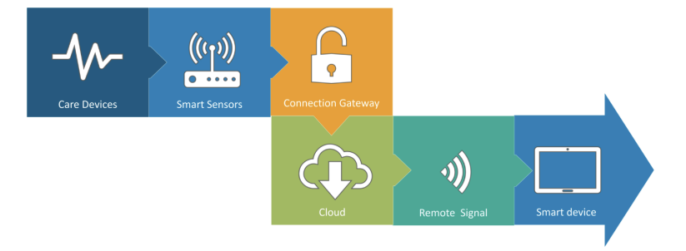

***Agriculture:***

A greenhouse farming technique enhances the yield of crops by controlling environmental parameters. However, manual handling results in production loss, energy loss, and labour cost, making the process less effective. A greenhouse with embedded devices not only makes it easier to be monitored but also, enables us to control the climate inside it. Sensors measure different parameters according to the plant requirement and send it to the cloud. It, then, processes the data and applies a control action.

***Industrial Automation :***

For a higher return of investment this field requires both fast developments and quality of products. This vitality thus coined the term IIOT. This whole schematic is re-engineered by IOT applications. Following are the domains of IOT applications in industrial automation

• Factory Digitalization

• Product flow Monitoring

• Inventory Management

• Safety and Security

• Quality Control

• Packaging optimization

• Logistics and Supply Chain Optimization

***Government and Safety:***

IOT applied to government and safety allows improved law enforcement, defence, city planning, and economic management. The technology fills in the current gaps, corrects many current flaws, and expands the reach of these efforts. For example, IOT can help city planners have a clearer view of the impact of their design, and governments have a better idea of the local economy.

**IoT Protocols :**

***Bluetooth :***

Bluetooth is a short range IOT communication protocol/technology that is profound in many consumer product markets and computing. It is expected to be key for wearable products in particular, again connecting to the IOT albeit probably via a smartphone in many cases. The new Bluetooth Low-Energy (BLE) – or Bluetooth Smart, as it is now branded – is a significant protocol for IOT applications. Importantly, while it offers a similar range to Bluetooth it has been designed to offer significantly reduced power consumption.

***Zigbee :***

ZigBee is similar to Bluetooth and is majorly used in industrial settings. It has some significant advantages in complex systems offering low-power operation, high security, robustness and high and is well positioned to take advantage of wireless control and sensor networks in IOT applications. The latest version of ZigBee is the recently launched 3.0, which is essentially the unification of the various ZigBee wireless standards into a single standard.

**Z-Wave :**

Z-Wave is a low-power RF communications IOT technology that primarily design for home automation for products such as lamp controllers and sensors among many other devices. A Z-Wave uses a simpler protocol than some others, which can enable faster and simpler development, but the only maker of chips is Sigma Designs compared to multiple sources for other wireless technologies such as ZigBee and others.

**Wi-Fi :**

Wi-Fi connectivity is one of the most popular IOT communication protocol, often an obvious choicefor many developers, especially given the availability of Wi-Fi within the home environment within LANs. There is a wide existing infrastructure as well as offering fast data transfer and the ability to handle high quantities of data. Currently, the most common Wi-Fi standard used in homes and many businesses is 802.11n, which offers range of hundreds of megabit per second, which is finefor file transfers but may be too power-consuming for many IOT applications.

**Cellular :**

Any IOT application that requires operation over longer distances can take advantage of GSM/3G/4G cellular communication capabilities. While cellular is clearly capable of sending high quantities of data, especially for 4G, the cost and also power consumption will be too high for many applications. But it can be ideal for sensor-based low-bandwidth-data projects that will send very low amounts of data over the Internet.

**NFC**

NFC (Near Field Communication) is an IOT technology. It enables simple and safe communicationsbetween electronic devices, and specifically for smartphones, allowing consumers to performtransactions in which one does not have to be physically present. It helps the user to access digital content and connect electronic devices. Essentially it extends the capability of contactless card technology and enables devices to share information at a distance that is less than 4cm.

About Sensors :

Sensor I : ***LDR (Light Dependant Diode)*** :

A photoresistor (also known as a photocell, or light-dependent resistor, LDR, or photo-conductive cell) is a passive component that decreases resistance with respect to receiving luminosity (light) on the component's sensitive surface. The resistance of a photoresistor decreases with increase in incident light intensity; in other words, it exhibits photoconductivity. A photoresistor can be applied in light-sensitive detector circuits and light-activated and dark-activated switching circuits acting as a resistance semiconductor.

In the dark, a photoresistor can have a resistance as high as several megaohms (MΩ), while in the light, a photoresistor can have a resistance as low as a few hundred ohms. If incident light on a photoresistor exceeds a certain frequency, photons absorbed by the semiconductor give bound electrons enough energy to jump into the conduction band. The resulting free electrons (and their hole partners) conduct electricity, thereby lowering resistance. The resistance range and sensitivity of a photoresistor can substantially differ among dissimilar devices. Moreover, unique photoresistors may react substantially differently to photons within certain wavelength bands.

A photoelectric device can be either intrinsic or extrinsic. An intrinsic semiconductor has its own charge carriers and is not an efficient semiconductor (such as silicon is). In intrinsic devices, most of the available electrons are in the valence band, and hence the photon must have enough energy to excite the electron across the entire bandgap.

Extrinsic devices have impurities, also called dopants, added whose ground state energy is closer to the conduction band; since the electrons do not have as far to jump, lower energy photons (that is, longer wavelengths and lower frequencies) are sufficient to trigger the device. If a sample of silicon has some of its atoms replaced by phosphorus atoms (impurities), there will be extra electrons available for conduction. This is an example of an extrinsic semiconductor.

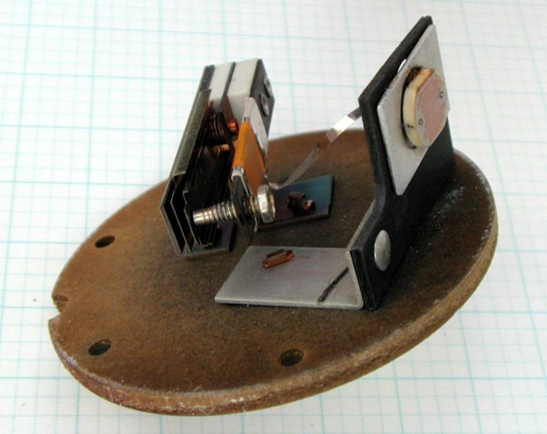

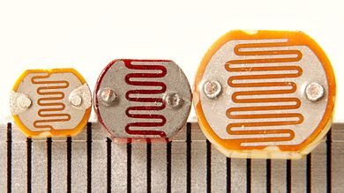

Use In our Project :

Existing in both the simulation and practical phase , the photocell helps us have light in the darkness. The responsibility of this sensor is to turn on the a LED when the light intensity goes below a certain threshold. Then we can manage to have light in the darkness.

Sensor II : ***The Encoder*** :

Position encoders are used to track the rotary position of a shaft or linear position of a load either indirectly with a motor mounted rotary encoder or directly with linear encoders.For linear position encoders, there are three basic approaches to tracking position:

* Indirect measurement using a position encoder on a rotary motor
* Indirect measurement using a linear encoder on a linear motor
* Direct readout using a position encoder on the load

As always, the selection process involves trade-offs. The most effective implementation depends upon the setup, the conditions, and the performance requirements of the application.

**Indirect measurement using a position encoder on a rotary motor :** This approach offers moderate performance but is straightforward to use. A rotary position encoder is installed on the shaft of a rotary motor to monitor shaft position. The position encoder provides an output corresponding to the rotation of the shaft, either in terms of voltage pulses when using incremental encoders or absolute angular position when using absolute encoders. The readout device, whether it is a controller, drive, or counter/display, needs to convert this data into the length of travel, then add this length of travel to the initial position to determine the final position.

The decision of whether to use an incremental or absolute position encoder should be driven by the application. For example, it is absolutely necessary for surgical robots to know its position when starting up, especially after a fault while performing surgery. In other cases, re-homing at startup is not a problem.

This configuration is easy to install and reliable. It supports direct feedback to the motor. Because the position encoder is not directly connected to the load, however, this method offers only limited accuracy. Error sources include couplers; shaft-to-shaft misalignment; gearbox backlash; and non-linearities introduced by accelerations, temperature variations, etc. In applications requiring a reversal of direction, hysteresis can be a problem, particularly when there is a significant amount of compliance in the system.

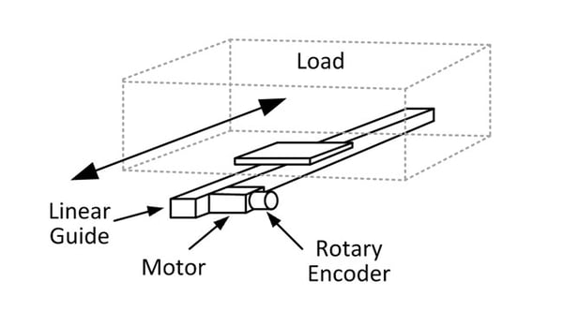

**Indirect measurement using a linear encoder on a linear motor :** Monitoring the motion of a load on a linear motor using a linear position encoder delivers much better accuracy. A linear motor is essentially a rotary motor unwound, so it generates linear motion directly. There is no need for a mechanical actuator. This eliminates several error sources.  
To measure the position of the load on a linear motor using a linear encoder, the linear scale needs to be affixed to the stationary part of the motor, typically the magnet track or the surface supporting it. The readout element of the encoder is mounted on the moving part of the motor, known as the forcer.

Once again, both incremental and absolute position encoders can be used. In each case, they provide the readout device with a measure of displacement that can be used to calculate the position of the load. An example of an indirect rotary encoder method is to use a draw string encoder. This is common in hydraulic cylinders.

This method provides better position accuracy than the rotary version. It must be used in an appropriate environment, however. The scale needs to be kept clean and in good condition. It needs to be properly mounted so that it is well aligned. Since these are both requirements for linear motors, however, these conditions are typically easy to meet.

Frequently, although not always, the load of a linear motor rides on a carriage attached to the moving portion of the motor. In cases like these, the system described above becomes equivalent to the third approach, which is direct readout of position using a linear encoder or another sensor.

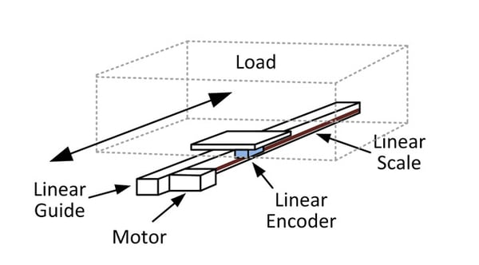

**Direct readout using a position encoder on the load :**

Applications requiring very high accuracy should use linear encoders mounted on the load. This direct-read method greatly reduces measurement error. It can be used with both linear motors and rotary motors driving linear actuators.

In this approach, the linear position encoder should be mounted external to the linear motor/linear actuator. As described above, the scale of the linear encoder should be mounted to a non-moving surface and the detector assembly should be affixed to the load. Particularly in the case of a ball screw actuator, mounting the encoder on the load removes much of the error in the system. At this point, the encoder becomes the primary error source for position location. Given that encoders typically outperform most system components, the direct approach makes it easy to achieve the accuracy and repeatability necessary for the application.

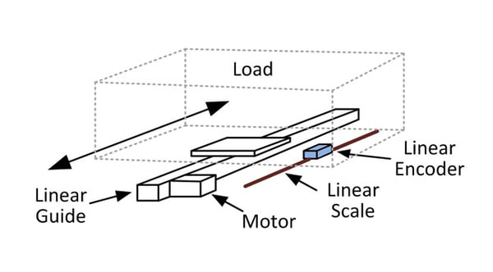

The technique is compatible with either incremental or absolute encoders. Incremental encoders can be used with interpolation techniques for very high-resolution while absolute versions have the advantage of reading out the position of the load directly. One example of a very high resolution device that has been employed in the configuration a laser interferometer.

The trade-off for all that accuracy is significantly greater challenge in the implementation. The approach increases cost and complexity while adding additional points of failure resulting in a reduction in overall system reliability. As with the previous example, the system is more vulnerable to contamination. Particularly in the case of very high-performance sensors, this must be considered.

Use In our Project :

We have a 6-volt DC Motor as one of our actuators (which we will discuss further in the report) there is an incremental 1024-pulse encoder coupled with it. With the help of the encoder we can monitor position or speed of the motor and use codes to control the speed.

Sensor III : ***Temperature-humidity sensor*** :

These sensors have been designed for various applications to measure the humidity as well as the temperature of the environment. They do so by finding the amount of water vapor present in the air around the sensors. The amount of moisture in the gas can be a mixture of different elements including nitrogen, water vapor, argon, etc. Since humidity can have huge effects on different biological, chemical, and physical processes, it should be measured and controlled in different industries and hence, there’s a need for these sensors to help us out.

Temperature and humidity sensors have two different ways of collecting data and measuring humidity and temperature. One type measures Relative Humidity (also known as RH) and the other type measures Absolute Humidity (also known as AH). They can also be categorized based on their size. Small sensors are used for smaller purposes and larger ones are usually used for industrial applications.

Some of these sensors are interfaced with a micro-controller for measuring the related data instantaneously. For example, the DHT11 temperature and humidity sensor are one of these digital temperature and humidity sensors with Arduino as its interface. It can also use other micro-controllers such as Raspberry Pi, etc.

These sensors have capacitive humidity sensing elements as well as a thermistor which is used to sense the environment’s temperature. There are two electrodes in the humidity sensing element (capacitor) and a moisture-holding substrate works as a dielectric between these two electrodes. Whenever there is a change in the humidity levels, changes occur to the capacitance value accordingly.

There’s an integrated IC in the unit that receives the measured data and processes the resistance values that have been changed due to the change in humidity and converts the data into a digital form for the readers. So, this is how digital temperature and humidity sensors such as DHT11 measure humidity. But what about the temperature?

The easiest explanation would be that these sensors use a negative temperature coefficient thermistor for measuring temperature. When there’s an increase in the temperature of the environment, this element would cause a decrease in its resistance value.

Moreover, some temperature and humidity sensors with displays have been designed which provide visual reporting of the humidity and the temperature and create a better experience for those using such sensors. Some of the newer temperature and humidity sensors with Wi-Fi have become popular these days as well that connect over Wi-Fi (or Bluetooth) enabling you to remotely monitor the humidity and the temperature of the place you’ve placed the sensor in with the help of an app that you can install on your phone. These sensors are great for when you are away and need to monitor the temperature and humidity of the place. They have pretty good accuracy too!

The accuracy of different temperature and humidity sensors differ from each other. For example, the DHT11 humidity sensor has an accuracy of 5% capable of measuring humidity up to 80 percent and its temperature sensor has a 2-degree accuracy with the ability to measure up to 50 degrees Celsius.

That is why for industries that are highly sensitive to keeping the temperature and humidity at a certain level, sensors with high accuracy are used because they provide more accurate and more reliable data. For example, meteorological and scientific research departments need sensors with full humidity measurements ranging from zero to 100 percent RH. Other fields don’t require the full range for their application purposes.

You should also know that the sensors that have a higher range usually cost higher than the ones with a lower measurement range. For example, the DHT11 we mentioned earlier is usually sufficient for a wide variety of applications and it costs less than the ones used for more sensitive applications. If you need to have more accuracy but still don’t have a great budget, the next best thing would be DHT22 temperature and humidity sensors.

Some applications : As we mentioned above, these sensors can be found in many devices and they have a wide variety of applications! They can even help patients who have trouble breathing by enabling them to keep the humidity and the temperature of the place at the optimum level. To predict weather conditions, weather stations use these sensors too. They can be used in heating systems, ventilation systems, and even air conditioning systems. These sensors can also be used for greenhouses where the humidity values should be checked constantly. Museums can benefit from them as well since the artifacts and the objects in these places should be kept under certain conditions.

Now you know all there’s to know about temperature and humidity sensors and their different models. Have you ever worked with these sensors directly? Comment below and let us know what you think about them and share your experience with us. Plus, feel free to sign up on Linquip to ask any questions you have from our experts who have years of experience in this industry.

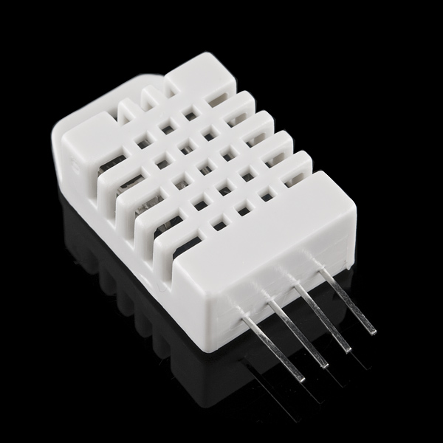

Use in our project :

The DC motor -as we will mention- is used as a Fan. In a home fan is needed when it’s hot so this sensor has the job to monitor temperature and to give the correct command to the motor to speed up , working roughly as an air conditioner.

Sensor IV : ***Gas Sensor*** :

Gas sensors are generally understood as providing a measurement of the concentration of some analyte of interest, such as CO, CO2, NOx, SO2, without at this point dwelling on the plethora of underlying approaches such as optical absorption, electrical conductivity, electrochemical (EC), and catalytic bead (see Section 3). However, and as discussed in Section 2, many other gas sensors measure a physical property of the environment around them, such as simple temperature, pressure, flow, thermal conductivity, and specific heat, or more complex properties such as heating value, supercompressibility, and octane number for gaseous fuels. The latter may require capital-intensive (engines) or destructive testing, for example, via combustion, or involve the measurement of a number of parameters to serve as inputs to a correlation with the complex property of interest.

When the sensor provides a multiplicity of outputs, as with optical or mass spectrometers (MSs), we refer to it as a gas analyzer. Gas chromatography (GC), differential thermal analysis (DTA), ion mobility, and nuclear magnetic resonance (NMR) are additional examples, some of which will be detailed in Section 4. Such analyzers, preferred by the author, should not be confused with sensor arrays, in which different sensing materials (typically polymers and metal oxides) are used on each element of the array, which then needs to conform to difficult-to-achieve stability requirements.

The performance of all of the above-mentioned sensors and analyzers may be characterized by their signal-to-noise (S/N) ratio, minimum detectable limit (MDL), selectivity, and response time. Increasingly, power consumption, size, and weight are becoming more important as interest and demand increases for handheld, battery-powered sensors, with or without wireless capability. These specifications may be viewed as simple performance parameters, because they are relatively simple to quantify.

Self-calibration, drift, S/N, and false alarm rate (FAR) (mainly for composition sensors or analyzers) require more sophisticated approaches, but are of increasing importance in all applications such as for medical, industrial, environmental, security, and first-responder use. Section 5 goes into the details of this subject.

Another classification of gas sensors and analyzers could be based on their sampling method: by diffusion, pumped transport, or via remote optical sampling to induce fluorescence, absorption, or scattering.

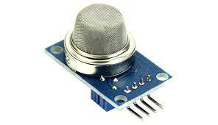

Use in our Project

This sensor is used only in simulation as a sumplimentary sensor , enabling us to model a smart house more efficiently and considerately and to take more parameters into account , while making the practical phase less costly to build.

Sensor V : ***Proximity Sensor***

A proximity sensor is a sensor able to detect the presence of nearby objects without any physical contact.

A proximity sensor often emits an electromagnetic field or a beam of electromagnetic radiation (infrared, for instance), and looks for changes in the field or return signal. The object being sensed is often referred to as the proximity sensor's target. Different proximity sensor targets demand different sensors. For example, a capacitive proximity sensor or photoelectric sensor might be suitable for a plastic target; an inductive proximity sensor always requires a metal target.[citation needed]

Proximity sensors can have a high reliability and long functional life because of the absence of mechanical parts and lack of physical contact between the sensor and the sensed object.

Proximity sensors are also used in machine vibration monitoring to measure the variation in distance between a shaft and its support bearing. This is common in large steam turbines, compressors, and motors that use sleeve-type bearings.

A proximity sensor adjusted to a very short range is often used as a touch switch.

Proximity sensors are commonly used on mobile devices. When the target is within nominal range, the device lock screen user interface will appear, thus emerging from what is known as sleep mode. Once the device has awoken from sleep mode, if the proximity sensor's target is still for an extended period of time, the sensor will then ignore it, and the device will eventually revert into sleep mode. For example, during a telephone call, proximity sensors play a role in detecting (and skipping) accidental touchscreen taps when mobiles are held to the ear.

Proximity sensors can be used to recognise air gestures and hover-manipulations. An array of proximity sensing elements can replace vision-camera or depth camera based solutions for hand gesture detection.

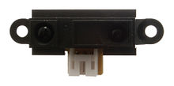

Use in our project :

This sensor is used only in simulation as a sumplimentary sensor , enabling us to model a smart house more efficiently and considerately and to take more parameters into account , while making the practical phase less costly to build.

Sensor Networking : ***Different Topologies***

**Star Topology :** In star topology, hub or switch is a single central node. In the network every node is connected to the hub. Star topology is very easy to implement, design and expand. As all the data flows through the hub, it plays an important role in the network and a failure in the hub can result in failure of entire network.

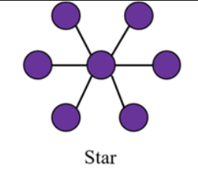

**Tree Topology :** A single root node at the top is connected to many nodes in the next level and this continues. The processing power and energy consumption is highest at the root node and keeps on decreasing as we go down the hierarchical order.

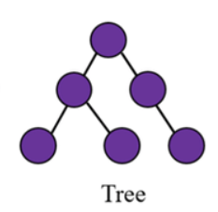

**Mesh Topology :** In a mesh topology, apart from transmitting its own data, each node also acts as a relay for transmitting data of other connected nodes. Fully Connected Mesh and Partially Connected Mesh were the two types of mesh topology.

Therefore, each node is connected to every other node in fully connected mesh topology. In partially connected mesh topology, a node is connected one or more neighboring nodes.

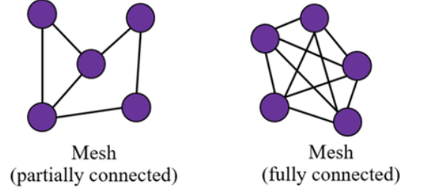

About Actuators

**The 6-volt DC motor** : Having been bought from a local store , it didn’t come with a datasheet so little is known about its specification. For our use we state that its nominal voltage is approximately 6‌volts and it's coupled with 1024-pulse encoder which then is controled with a driver. We program it such that its speed could be controled , while rotating in one direction.

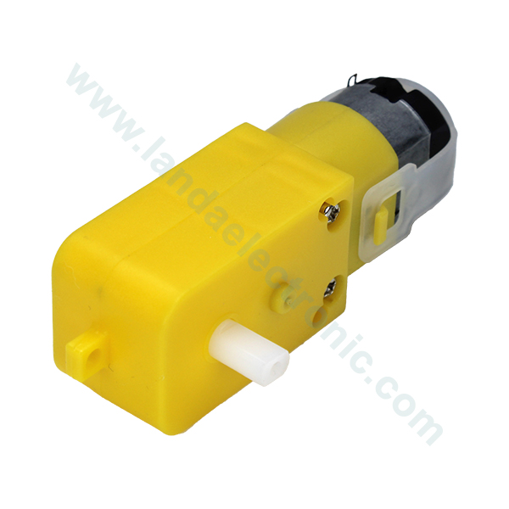

**The LED and the Alarm LED :**

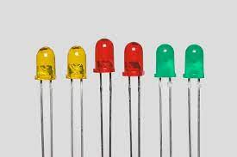

About the interface :

How to watch and monitor :

This is where IoT steps in to make our lives easier and smarter , for this purpose we use a pre-written software called Blynk. Blynk is familiar with Arduino NodeMCU -the board of our choice- and we can customize its interface to our liking. It can both monitor or send commands to our NodeMCU

How to Control :

Blynk comes as a webserver or smartphone interface turning your PC or smartphone into an interface to control and monitor your board in each instance of time.



**What do we want from an MCU:**

The data collected in a home automation system is usually processed and managed by a microcontroller. The chosen MCU will have to operate accordingly and make some decisions based on the collected data. The MCU is the absolute heart of an IOT-based home automation service since, without an MCU, we won’t reach the desired results.

**What are some recommended MCUs for our use:**

Some recommended MCU’s for our use are:

1- Raspberry Pi

2- Arduino

3-NodeMCU

**Raspberry Pi:**

Raspberry Pi is a small single microcontroller computer. With a higher RAM of 256MB or 512Mb, depending on the model, it can handle more complex tasks than other controllers and used mostly as a central processing unit for multiple devices. Most new models of Raspberry Pi have USB and Ethernet ports, making it easy to upload data to the internet.

**Arduino:**

Arduino is a single-board microcontroller that can be simply programmed to execute commands. Arduino comes in a variety of models with onboard flash memory ranging from 32kB to 512kB, and a typically a RAM of 2kB. Evidently, this controller is less powerful than the Raspberry Pi. However, most Arduino models are cheaper, easier to handle, and powerful enough to deal with home automation tasks.

**Node MCU:**

It is an Arduino based microcontroller but with the addition of the ESP8266 Wi-Fi chipset. This microcontroller has a memory of 128kB and a 4MB storage. It is mostly used for a single IOT application, or to eliminate the need for a central processing unit. Since each part of the system can upload data to the server individually, this also lowers the complexity of the coding and the connection chain [6]. The biggest advantage of the NodeMCU over the other alternatives is the significantly low price for a controller that can connect to the internet directly using Wi-Fi, without the need for any additional peripherals of modules. An issue is that the NodeMCU board has only one analog input, which limits its applications to as single data monitoring system. However, this drawback can be compensated for by using the ASD115, which is an analog to digital converter that has four analog input pins and has a higher conversion resolution of 16-bits.

**Node MCU:**

NodeMCU (Node Microcontroller Unit) is a low-cost open source IOT platform. It initially included firmware which runs on the ESP8266 Wi-Fi SoC from Espressif Systems, and hardware which was based on the ESP-12 module. Later, support for the ESP32 32-bit MCU was added. NodeMCU is an open source firmware for which open source prototyping board designs are available. The name “NodeMCU” combines “node” and “MCU” (micro-controller unit). The term “NodeMCU” strictly speaking refers to the firmware rather than the associated development kits. Both the firmware and prototyping board designs are open source. The firmware uses the Lua scripting language. The firmware is based on the eLua project, and built on the Espressif Non-OS SDK for ESP8266. It uses many open source projects, such as lua-cjson and SPIFFS. Due to resource constraints, users need to select the modules relevant for their project and build a firmware tailored to their needs. Support for the 32-bit ESP32 has also been implemented. The prototyping hardware typically used is a circuit board functioning as a dual in-line package (DIP) which integrates a USB controller with a smaller surface-mounted board containing the MCU and antenna. The choice of the DIP format allows for easy prototyping on breadboards. The design was initially based on the ESP-12 module of the ESP8266, which is a Wi-Fi SoC integrated with a Tensilica Xtensa LX106 core, widely used in IOT applications.

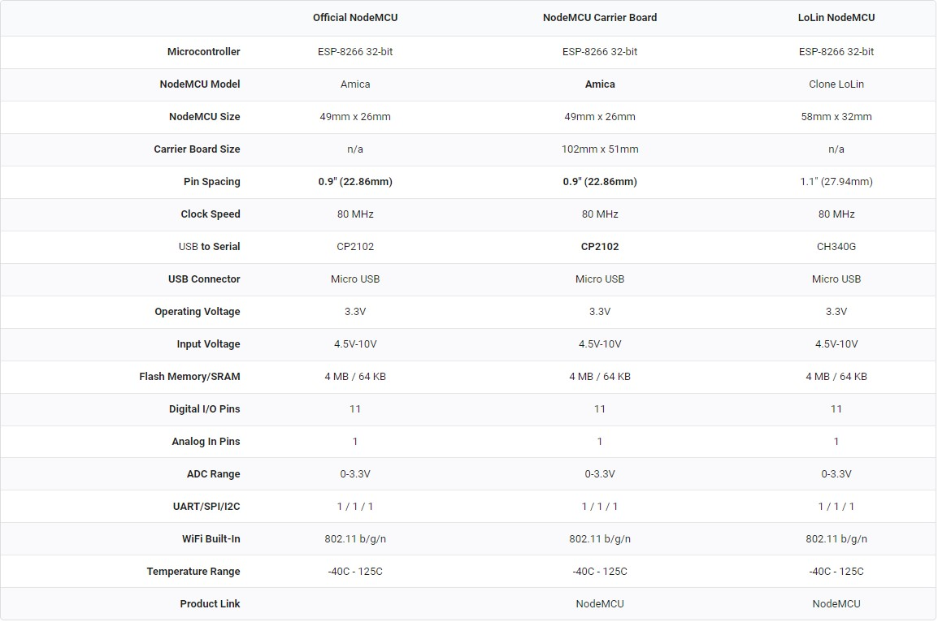**NodeMCU Technical Specifications:**

## NodeMCU Pinout and Functions Explained

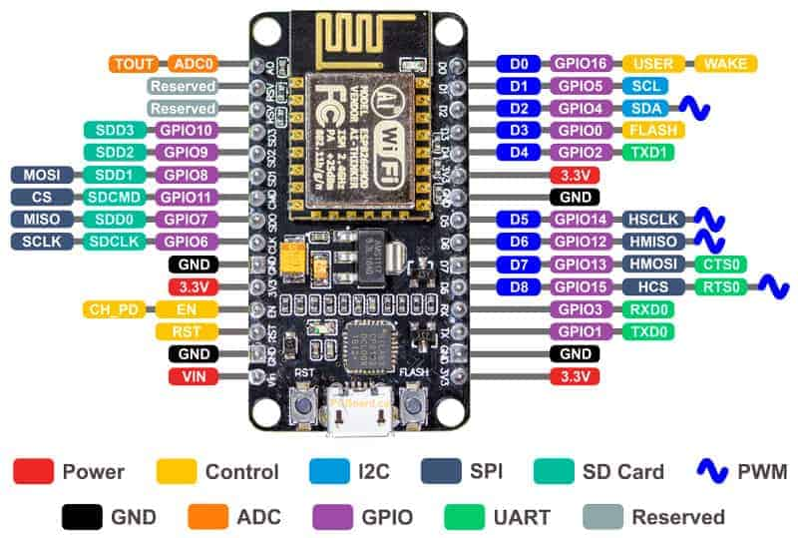

**Power Pins:**There are four power pins. **VIN** pin and three **3.3V** pins..

**VIN:**can be used to directly supply the NodeMCU/ESP8266 and its peripherals. Power delivered on **VIN** is regulated through the onboard regulator on the NodeMCU module – you can also supply 5V regulated to the **VIN** pin

**3.3V** pins are the output of the onboard voltage regulator and can be used to supply power to external components.

**GND:** are the ground pins of NodeMCU/ESP8266

**I2C Pins:** are used to connect I2C sensors and peripherals. Both I2C Master and I2C Slave are supported. I2C interface functionality can be realized programmatically, and the clock frequency is 100 kHz at a maximum. It should be noted that I2C clock frequency should be higher than the slowest clock frequency of the slave device.

**GPIO Pins:** NodeMCU/ESP8266 has 17 GPIO pins which can be assigned to functions such as I2C, I2S, UART, PWM, IR Remote Control, LED Light and Button programmatically. Each digital enabled GPIO can be configured to internal pull-up or pull-down, or set to high impedance. When configured as an input, it can also be set to edge-trigger or level-trigger to generate CPU interrupts.

**ADC Channel:**The NodeMCU is embedded with a 10-bit precision SAR ADC. The two functions can be implemented using ADC. Testing power supply voltage of VDD3P3 pin and testing input voltage of TOUT pin. However, they cannot be implemented at the same time.

**UART Pins:** NodeMCU/ESP8266 has 2 UART interfaces (UART0 and UART1) which provide asynchronous communication (RS232 and RS485), and can communicate at up to 4.5 Mbps. UART0 (TXD0, RXD0, RST0 & CTS0 pins) can be used for communication. However, UART1 (TXD1 pin) features only data transmit signal so, it is usually used for printing log.

**SPI Pins:** NodeMCU/ESP8266 features two SPIs (SPI and HSPI) in slave and master modes. These SPIs also support the following general-purpose SPI features:

4 timing modes of the SPI format transfer

Up to 80 MHz and the divided clocks of 80 MHz

Up to 64-Byte FIFO

**SDIO Pins:** NodeMCU/ESP8266 features Secure Digital Input/Output Interface (SDIO) which is used to directly interface SD cards. 4-bit 25 MHz SDIO v1.1 and 4-bit 50 MHz SDIO v2.0 are supported.

**PWM Pins:** The board has 4 channels of Pulse Width Modulation (PWM). The PWM output can be implemented programmatically and used for driving digital motors and LEDs. PWM frequency range is adjustable from 1000 μs to 10000 μs (100 Hz and 1 kHz).

**Control Pins:** are used to control the NodeMCU/ESP8266. These pins include Chip Enable pin (EN), Reset pin (RST) and WAKE pin.

**EN:** The ESP8266 chip is enabled when EN pin is pulled HIGH. When pulled LOW the chip works at minimum power.

**RST:** RST pin is used to reset the ESP8266 chip.

**WAKE:** Wake pin is used to wake the chip from deep-sleep.

Control Pins are used to control the NodeMCU/ESP8266. These pins include Chip Enable pin (EN), Reset pin (RST) and WAKE pin.

**EN:** The ESP8266 chip is enabled when EN pin is pulled HIGH. When pulled LOW the chip works at minimum power.

**RST:** RST pin is used to reset the ESP8266 chip.

**WAKE:** Wake pin is used to wake the chip from deep-sleep.